Adaptive Federated Learning for DDoS Attack Detection
Dogiparthi Harini ¹, Pamala Thanmai², Umesh³
^{1,2,3}School of Computer Science and Engineering, Vellore Institute of Technology, Chennai-600127
Corresponding author: Umesh(e-mail: ).
ABSTRACT The increase of Distributed Denial-of-Service (DDoS) attacks leads to significant challenges to network security. Traditional machine learning approaches for DDoS detection may face scalability issues and data risks such as privacy concerns and data leakage due to centralized data collection. Our project proposes a Federated Learning-based system for DDoS attack detection by addressing these issues by decentralized model training across edge devices such as network nodes or routers. The proposed model consists of CLA-Net (Convolution LSTM Attention Network) architecture with convolution layers and Bidirectional LSTM. The Federated Learning provides privacy by transmitting only model weights rather than raw data. Detection of DDoS attacks, including Syn, UDP, MSSQL, NetBIOS, LDAP, and UDPLag attacks, is achieved through continuous monitoring of network traffic. By combining Federated Learning approach FedProx with CLA-Net Architecture, our project provides an effective and scalable solution for DDoS attack detection in a network. CLA-Net architecture with Federated Learning have achieved an accuracy of 99% respectively. The precision, recall and F1-score of 95%, 97% and 96% respectively. The CLA-Net combined with Federated Learning achieves better accuracy, performance and results than the original CNN model which has an accuracy of 75%.
INDEX TERMS CLA-Net (Convolution LSTM Attention Network), Federated Learning, Client Model, Global Model, DDoS attacks, FedProx, Momentum-based Aggregation.
- INTRODUCTION
A DDoS (Distributed Denial of Service) attacks gets down a server, network and websites with excessive traffic, causing disruption and downtime of the websites. It is crucial to detect the different types of DDoS attacks as they can cause severe damage to the services that are provided, lead to financial loss and threat to the cyber security. With the rise of technology, DDoS detection and prevention methodologies are essential to maintain system reliability and security. A growing number of Distributed Denial-of-Service (DDoS) attacks creates security risks for the networks which grow worse as these attacks become larger and more complex. Modern DDoS detection approaches using central data centers deal with multiple significant challenges because of their centralized data collection and processing architecture. Privacy risks emerge because sensitive information requires transmission to central servers despite scalability [6].

Fig. 1 represents the yearly increase in percentage of DDoS attacks across various years. From 2015 to 2019 there observed a highest increase of DDoS attacks. This fluctuating trends from the graph indicates variation in frequency of DDoS attacks over the years [1, 2].
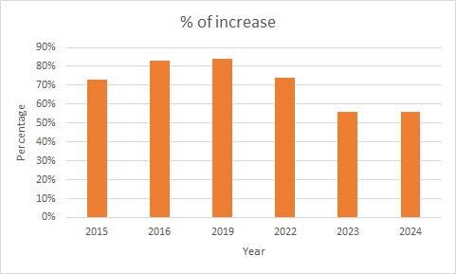
Figure 1: Year by year increase of DDoS attacks

The solution of these problems requires finding innovative solutions which maintain privacy standards while detecting rapid DDoS attack. The decentralized learning approach called Federated Learning trains distributed edge devices to conduct model updates without data sharing. Devices under this approach perform model updates automatically before they transmit the computed data to a central server which ensures data privacy protection. FL has become widely adopted in different domains because it allows model training without exposing sensitive information [22].

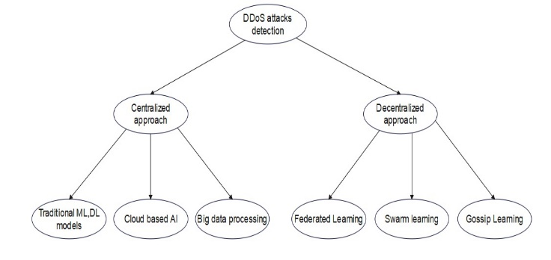
Figure 2: Types of Approaches

As shown in Fig. 2, DDoS attack detection falls into two different ways as centralized and decentralized approaches. The centralized approach depends on the single system for the attack detection, using Traditional ML/AI models, Cloud-based AI, and Big data processing to analyze network traffic and detect DDoS attacks. Decentralized approach relies on multiple devices, enhancing security. It includes Federated Learning(where models are trained across multiple devices without sharing data), Swarm Learning and Gossip Learning methods for decentralized model weight updates. This classification helps us to find the best approach for DDoS attack detection.
A CLA-Net (Convolution LSTM Attention Network) is a computational model which got inspired by the human brain, consisting of many interconnected layers of neurons with deep architecture that process and learn from data. CLA-Net is widely used for tasks like classification, regression, and pattern recognition due to its ability to capture complex relationships in data. It is preferred because of its adaptability, self-learning, and high accuracy in solving non-linear problems in various domains [4].
The suggested approach employs FL approach FedProx with CLA-Net (Convolution LSTM Attention Network) as fundamental components to deploy a protective solution for networks against DDoS attacks. Multiple architectural changes were implemented to the CLA-Net design for better model effectiveness together with improved robustness. The system integrates Lasso and Ridge regularization methods as regularization techniques to reduce overfitting and enhance model generalization for unseen data. The experimental process tests more advanced activation functions like ReLU, softmax to optimize learning to accelerate and stabilize the training of the network we have added batch normalization. The system combines architectural developments and FL to achieve distributed model update computation and managed information sharing thereby minimizing expenses and safeguarding personal data. DDoS attack detection can now have an efficient and scalable solution.
Fig. 3 explains the distribution of DDoS attacks, with UDP Flood being the most prevalent at 67%, followed by Multivector Attacks at 15%.Other types include SYN Flood (9%), IP Flood (7%), and TCP Flood (2%), indicating that volumetric attacks(UDP Flood, IP Flood, Multivector Attacks) dominate protocol-based ones(SYN Flood, TCP Flood)[3].

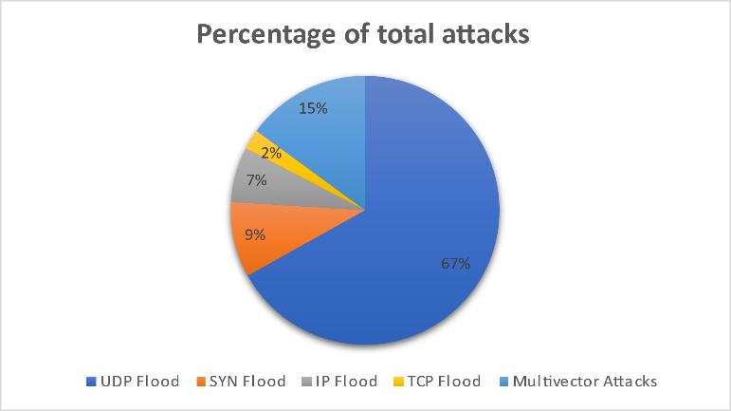
Figure 3: Types of DDoS Attacks

Syn Attack: Exploits TCP handshake protocol by sending large number of synchronizing requests to a server but do not complete hand shake. Causes the server to exhaust resources while waiting for connections that never complete, leading to DOS (Denial of Service).
UPD Attack: Sends large amounts of User Datagram Protocol (UDP) packets to random ports in a system, the server checks whether any of the application are listening on these ports which leads to high processing load. This consumes more bandwidth which causes service disruption.
MSSQL Attack: Exploits Microsoft DQL server by sending requests that generate large responses, which directed towards user and these are often used in amplification attacks. These increases traffic significantly and leads to overload of targets network.
LDAP Attack: Abuses Lightweight Directory Access Protocol (LDAP) servers to amplify attack traffic. The attacker spoofs the user's IP address and sends small queries that generate large responses. These causes a high-volume DDoS attack, overwhelming network infrastructure.
NetBIOS Attack: Exploits NetBIOS Name Service (NBNS) by sending spoofed requests to the servers, which causes a flood of unwanted responses. It can be used for network disruption and amplification which leads to downtime of service.
UDPLag Attack: This attack targets online gaming and VoIP services by flooding the networks with User Datagram Protocol packets which causes increased latency and packet loss. This attack creates lags or disconnects players or users from services that affects performance.

The proposed research work introduces a Federated Learning-based CLA-Net (Convolution LSTM Attention Network) model for DDoS attack detection, enabling privacy-preserving and decentralized training across edge devices. The system efficiently detects various DDoS attack types, including SYN, UDP, MSSQL, NetBIOS, LDAP, and UDPLag, through continuous network traffic monitoring. This approach provides a scalable, secure, and efficient solution for network security, addressing the limitations of centralized detection systems.

- Literature Review
Bhatia et al., [5] discussed innovative methods for detecting and mitigating Distributed Denial of Service (DDoS) attacks across different settings. They explored the use of Federated Learning to detect DDoS attacks in IoT environments, which are often limited in resources. By training models on both Identically Distributed (IID) and Non-Identically Distributed (Non-IID) datasets, this approach prioritizes user privacy while addressing the challenges of traditional AI-based security systems in IoT networks. Maiga et al., [6] addressed DDoS mitigation in 5G core networks by combining eXtreme Gradient Boosting (XGBoost) for feature extraction with a hybrid Deep Neural Network. Federated Learning enables distributed training across Virtual Network Functions (VNFs), ensuring privacy while maintaining high accuracy, low false positives, and quick detection times, as demonstrated using the CICDDoS2019 dataset. Saveetha et al., [7] integrated Federated Machine Learning (FML) with blockchain technology to enhance DDoS detection and resolve issues like model poisoning and miner selection. Using a dynamic reputation-based mechanism, this approach, tested with Random Forest, Multilayer Perceptron, and Logistic Regression algorithms, achieved an impressive 99.1% accuracy with Random Forest, proving its reliability in safeguarding blockchain networks and detecting DDoS attacks effectively.

Mahadik et al., [8] investigated the protection of heterogeneous IoT applications from DDoS attacks through an Edge-Federated Learning (Edge-FL)-based Intrusion Detection System (IDS). Combination of Edge Computing (EC) and Federated Learning (FL) and Deep Learning (DL) a CNN-based classifier performed training on the dataset. The detection accuracy reached 96.98%. Li, K et al., [9] explored how a distributed NIDS based on FL stands as a solution to deal with security problems in satellite-terrestrial integrated networks by managing resource distribution while detecting DDoS attacks. The proposed satellite network topology optimization combined with FL adaptation for STIN achieves better performance by outperforming traditional deep learning-based intrusion detection methods in all identified performance benchmarks such as malicious traffic recognition rate and packet loss rate and CPU utilization. Ferrag et al., [10] introduced Edge-IIoTset as a detailed cybersecurity dataset which supports centralization detection but also functions for FL-based intrusion detection of IoT and Industrial IoT (IIoT) applications. The generated dataset from an IoT test study includes 14 attack types within five threat categories like DDoS attacks and information gathering and malware attacks. With the analysis of 61 features extracted from 1176 features the this provides exploratory evaluation of machine learning performance that operates in centralized and federated learning environments.

Nguyen et al., [11] introduced DeepMonitor as a traffic monitoring framework which enhances fine-grained traffic analysis capabilities at the network edges of SDN-based IoT networks. A federated DDQN-based traffic monitoring mechanism operates to create substantial advantages in learning output. The DDoS attack detection capability of DeepMonitor reaches 22.83% higher performance levels when compared to FlowStat. Li J, [12] explored Federated Learning (FL) in combination with edge and fog computing serves as the main element for fighting malicious code in IIoT networks. A proposed detection protocol based on FL trains distributed data in a global model and protects against data and communication limitations. The detection accuracy of the FL-based model reaches approximately 98% levels which match those of centralized training methods. Liu et al., [13] a novel LSTM-CGAN model identifies Low-Rate Distributed Denial of Service (LDDoS) attacks in blockchain-based wireless networks. The approach begins by examining LDDOs attack features which serves as the starting point to model network packet sequences with LSTM networks and to use CGAN to develop adversarial LDDOs attack samples.

Alhasawi et al., [14] proposed a method FL-DAD, which uses Convolutional Neural Networks (CNNs) to detect DDoS attacks directly at the source, all while preserving data privacy. Pourahmadi et al. [15] focused on FedOE, a Federated Learning framework that incorporated Outlier Exposure-enabled Autoencoders (oAE) for better anomaly detection. Even with only 50 labeled attack flows per edge server, the oAE model achieves high F1-scores and performs better than conventional autoencoders, demonstrating its effectiveness in detecting new, previously unseen attacks. Zhang et al. [16] presented FLDDoS, which enhanced Federated Learning with K-Means-based aggregation and SMOTEENN for handling imbalanced datasets. This model improved detection accuracy by 4% over traditional methods and significantly reduced communication rounds by 40%, showcasing how Federated Learning can efficiently collaborate to improve DDoS detection.

Kautish et al., [17] introduced SDMTA which represents a new architectural approach for Hybrid Cloud DDoS mitigation. SDMTA reaches superior performance through network monitoring integration surpassing standard models with detection results of 99.7% accuracy along with 98.32% specificity and 99.92% sensitivity. Dao et al., [18] demonstrated FOGshield which operates as a localized DDoS prevention framework through federated fog computing technology for network border deployment of smart endpoint devices. The central device trains the supervising defenders with attack behavior-based self-organizing maps. The FOGshield framework achieves superior attack defense capabilities than current solutions when tested through various IoT traffic simulations according to performance analysis. Almadhor et al., [19] adopted Explainable Artificial Intelligence (XAI) and Federated Deep Neural Networks (FDNNs) to determine and prevent DDoS attacks within IoT networks with strict attention to privacy and extensive scalability. The proposed method trains FDNNs across multiple distributed datasets but uses XGBoost together with SHapley Additive exPlanations (SHAP) as a feature selection tool which improves interpretability levels. The experimental data demonstrates an accuracy rate of 98.78% as well as precision at 99.80% and recall at 99.74% and F1 score at 99.76% validating FL-based intrusion detection systems as strong security mechanisms for IoT network protection from progressive cyber dangers.

The distributed network security enhancement solution known as Federated Learning operates as a promising innovation for DDoS attack detection alongside protection of distributed network data privacy. Without sharing testing data, the FLAD technique directs enhanced computational resources towards difficult attack patterns which leads to superior accuracy rates combined with faster convergence on unbalanced and heterogeneous DDoS attack detection datasets [20]. The Federated Learning-based DDoS Detection (FLDDoS) system combined FL with a Convolutional Neural Network (CNN) during feature extractions and implemented model mixing solutions for non-IID data to reach a 90% accuracy in multiclass DDoS classifications and 99% in binary DDoS detection and exceeds traditional approaches by 20% performance rates [21]. The Federated Learning-based Anomaly Detection (FedLAD) system uses FL technology to protect SDN architectures through multiple controllers and simultaneously reduces operational resource use. The FedLAD system reaches accuracy rates exceeding 98% during its evaluations on the InSDN, CICDDoS2019, and CICDoS2017 datasets while proving its ability to scale effectively in SDN deployments. FL demonstrates its potential towards DDoS security enhancement in different network environments through experiments that protect privacy resources and deliver stronger model accuracy [22].
Multiple literature surveys examine how Federated Learning progresses in the prevention of Distributed Denial-of-Service (DDoS) and Botnet attacks throughout IoT, blockchain, 5G, SDN and industrial network environments. FL contributes to information security by maintaining user privacy alongside low-performance overheads as well as distributed training capabilities across distributed systems. Different Federated Learning models achieve high detection accuracy such as 99.1% for blockchain-based DDoS detection, 98.37% for Industry 4.0 security and 100% for detecting DoS and DDoS attacks in IoT networks. Deep learning algorithms with dynamic aggregation and reputation mechanisms and hybrid architecture design to boost security performance and manage diverse data along with system resources.

- Proposed Methodology
Fig. 4, the proposed architecture for DDoS detection using Federated Learning approach FedProx and CLA-Net (Convolution LSTM Attention Network) follows a structured approach to detect DDoS attack. The proposed model uses the CICDDoS2019 dataset, which contains various types of DDoS attacks and benign traffic data. The dataset undergoes data preprocessing, including data cleaning, data splitting, and feature extraction, to prepare it for training. Then the preprocessed data is used to classify network traffic into multiple DDoS attack types such as UDP, NetBIOS, UDPLag, LDAP, MSSQL, and SYN attacks. The CLA-Net model is trained on the preprocessed data, with separate training and testing phases. To enhance the efficiency, Federated Learning approach FedProx is used, allowing multiple clients to train the CLA-Net models independently. These local models update their weights, which are aggregated in the global CLA-Net model in the server without sharing raw data. The final trained global model improves the detection of DDoS attacks while maintaining scalability.

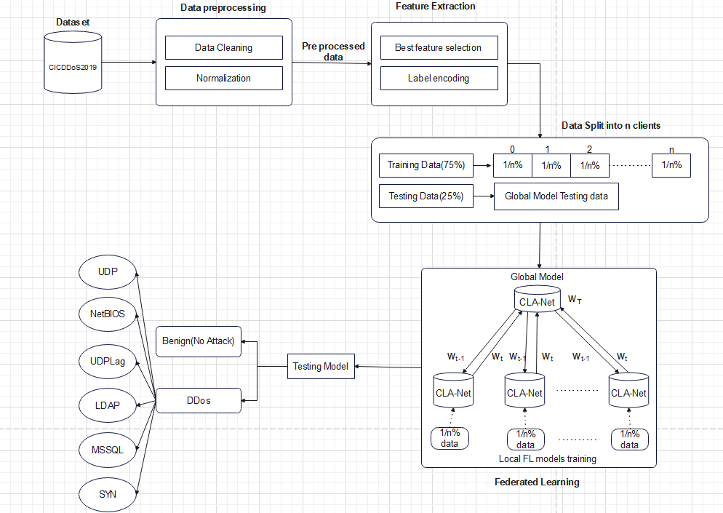
Figure 4: Proposed Architecture

- DATASET DESCRIPTION
The dataset used in this study is CIC-DDoS2019 [23].This is an academic intrusion detection dataset. The main purpose of this dataset is to detect the different types of DDoS attacks. The dataset provides an extended set of Distributed Denial of Service attacks, most of which employ some form of amplification through reflection. The dataset shares its feature set with the other CIC NIDS datasets DoS2017[24], IDS2017[25] and IDS2018[26]. CICDDoS2019 is a balanced dataset with a total of 1,58,987 records were 1,20,065 are train and 38,922 are test. The data split in percentage between train and test are 75.52% and 24.48% respectively. This dataset contains six different types of DDoS attacks: SYN, Benign, UDP, MSSQL, LDAP, NetBIOS and UDPLag.
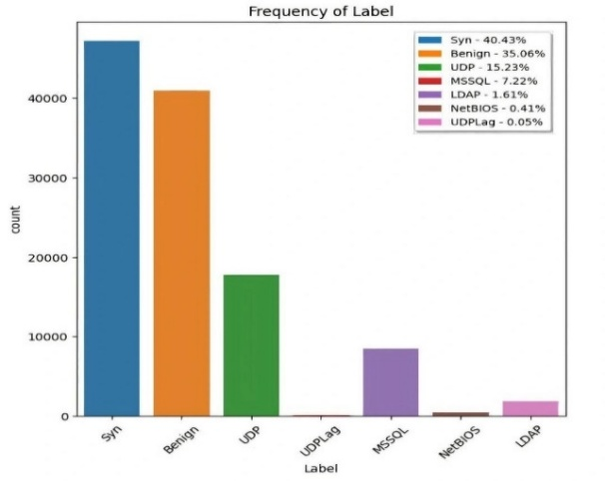
Figure 5: Data Classification
TABLE I
DATASPLIT OF DDOS ATTACK
Image Split | DDoS types | Count
Train | Benign | 42007
 | Syn | 48840
 | UDP | 18090
 | MSSQL | 8523
 | LDAP  NETBIOS  UDP Lag | 1906  644  55
Test | Benign | 10847
 | Syn | 533
 | UDP | 10420
 | MSSQL | 6212
 | LDAP  NETBIOS  UDP Lag | 1440  598  8872
Total |  | 1,58,987

- Data Preprocessing
The Data Pre-processing Module prepares the source data through cleaning steps ready for model training purposes. There are total of seventy-seven features in the dataset. During pre-processing, network traffic gets prepared through techniques including feature extraction with normalization strategies and missing data management to create proper training input data. Missing data is handled by calculating the median of the column and replace it in place of missing values. Normalization is a data preprocessing step that scales numerical values to a standard range for model performance improvement. Min-Max Normalization technique is used for the packet length and flag count columns. As mentioned in (1) the Min-Max normalization is done for the features of dataset mentioned in Table. III. Feature extraction identifies the most informative network traffic attributes for detecting DDoS attacks. The columns are divided into packet Based features such as Packet size, Protocol type., and Flow-Based Features such as Flow duration, Flow Bytes per Second.

TABLE II
Min-Max Normalization on Features of dataset
S.NO | Feature Name | Original value | Min value | Max value | Normaized value
1 | Flow duration | 5000000 | 1000 | 10000000 | 0.4999
2 | Total Fwd packets | 20 | 1 | 2000 | 0.0095
3 | Total Bwd packets | 15 | 1 | 1500 | 0.0093
4 | Flow Bytes | 800000 | 100 | 10000000 | 0.0799
5 | Flow Packets | 250 | 0.1 | 5000 | 0.0499
6 | Fwd/Bwd packet length | 1300 | 1 | 1514 | 0.8585

$X^{'}=\frac{X-X_{min}}{X_{max}-X_{min}}$………… (1)
X = Original feature value
X_{min} = Minimum value of the feature
X_{max}= Maximum value of the feature
X$'$= Scaled value in the range [0,1]
The Feature extraction method used is Principal Component Analysis (PCA). PCA is a dimensionality reduction approach that converts high-dimensional data into a lower-dimensional data. After the feature extraction the number of columns is reduced from seventy-seven to sixty-six. The detection of DDoS attack patterns depends on the feature extraction process that identifies important network traffic attributes such as packet rates and protocol types. During model training the normalization procedure standardizes data values suitable for decentralized FL training. CLA-Net (Convolution LSTM Attention Network) architecture requires the pre-processed data as its fundamental input. The input size of an CLA-Net is same as the number of features extracted from network traffic data that is sixty-six.

- CNN-Net Architecture

The proposed CNN-Net architecture is composed of several deep learning components structured in a sequential manner to enhance feature extraction, temporal analysis, and attention-based pattern recognition. Unlike a traditional CNN, this architecture does not consist of simple input, hidden, and output layers. Instead, it integrates 1D Convolutional layers, Bidirectional LSTM, and Multi-Head Attention mechanisms, followed by pooling and dense layers for classification.

Input Representation: The input to the model consists of 66 extracted features per data sample. The raw input vector is represented as:
x_{i} = [x_{i1} ,x_{i2} ,...,x_{i66} ] …………………………… (2)
Where x_{i} denotes the input vector for the i^{th} sample.
The input is reshaped to a 2D format suitable for 1D convolution:
x_{i}^{reshaped} ∈ R^{66×1}
Convolutional Feature Extraction Block: Two Conv1D layers are used for local pattern extraction:
First Conv1D: 128 filters, kernel size = 5, ReLU activation Second Conv1D: 64 filters, kernel size = 3, ReLU activation A Layer Normalization step is applied after the first convolutional layer for stable learning. Dropout is applied after the second layer to avoid overfitting.

Let z₁ and z₂ be outputs after the first and second convolutional layers respectively.
ReLU activation:
a = max(0,z) ………………………………….…… (3)
a = ReLU
If z>0, output is z
If z$≤$0, output is 0

Sequence Modeling with BiLSTM: The output of the CNN block is passed to a Bidirectional LSTM to learn temporal dependencies in both forward and backward directions:
Let the BiLSTM output be denoted by h ∈R^{66×128}

Attention Mechanism: A Multi-Head Attention layer is applied to learn dependencies across time steps and improve focus on critical features. To further refine feature learning, a multi-head self-attention layer is employed. This mechanism enables the model to weigh the importance of different feature positions in the sequence and identify global interactions.
Let the input to the attention layer be h. The attention output is:
A= MultiHeadAttention(Q = K = V = h) ………………(4)
A residual connection is applied between the attention output and the BiLSTM output to preserve original information:
h_{res} = h+A…………………………………… (5)

To improve model convergence and stabilize learning, Batch Normalization is applied after each activation function. Equation (6) and (7) are the mathematical expressions for the Batch Normalization layer.
$\hat{x}=\frac{x-μ}{σ}$…………………………………………….… (6)
$y= γ\hat{x}+β$……………………………………..…… (7)

x = Input before normalization,
$μ, σ$ = Mean and standard deviation of the batch,
$\hat{x}$ = Normalized input,
$γ,β$ = Learnable scale and shift parameters

The attention mechanism allows the model to Capture relationships across non-adjacent features. Focus on key aspects of the traffic pattern. Mitigate information loss from earlier layers.

Global Pooling and Classification Block: A Global Max Pooling 1D layer is applied to reduce the sequence to a fixed-length vector. This is followed by a Dense Layer with ReLU and dropout, and finally the output Dense layer. For classification, two scenarios are handled:
1. Binary Classification (e.g., Benign vs DDoS): Uses Sigmoid activation:
$P\left(y\right)= \frac{1}{1+e^{-z}}$………………………………….…… (8)
Where
y = Predicted output
P(y) = Sigmoid function
z = Logit (weighted sum of inputs before activation).
e^{-z}= Exponential function used to fit the range 0 to 1.
2. Multi-class Classification (e.g., DDoS type): Uses Softmax activation:
$P\left(y_{i}\right)=\frac{ⅇ^{z_{i}}}{\sum_{j=1}^{C}{ⅇ^{z_{j}}}}$………………………………….… (9)
Where
$y_{i}$ = Logit (raw score) for class i
C = Total number of classes
$ⅇ^{z_{j}}$$ⅇ^{z_{i}}$= Exponential of the logit
$\sum_{j=1}^{C}{ⅇ^{z_{j}}}$=Normalization factor to make the output sum to 1

Loss Function: This research work uses multi class classification, and hence sparse categorical cross entropy is used as loss function. Equation (10) measures the difference between true labels ($y_{i}$) and predicted labels (${\hat{y}}_{i}$), used for multi-class classification.

$L=-\sum_{i=1}^{N}{y_{i}\log\left({\hat{y}}_{i}\right)}$……………………….……… (10)
Where:
N= number of training samples
y_{i}= true class label
${\hat{y}}_{i}$= predicted probability

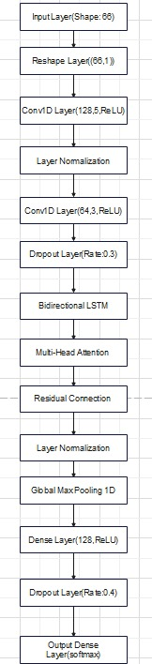
Figure 6: Layered Architecture for CNN-CLA-Net

Fig. 6 illustrates the enhanced layered architecture of the CLA-Net CNN model used for accurate and robust DDoS attack detection. This architecture integrates various deep learning components such as convolutional layers, BiLSTM, and multi-head self-attention to effectively learn spatial and temporal representations from the network traffic features. The input to the model consists of structured network traffic data with 66 extracted features. These are reshaped and passed into a 1D Convolutional block. The first Conv1D layer with 128 filters and kernel size 5 uses a ReLU activation function to extract low-level spatial features from the input. This is followed by a Layer Normalization layer that standardizes the outputs to improve convergence and stability. A second Conv1D layer with 64 filters and a smaller kernel size of 3 further refines the spatial patterns, and a Dropout layer with a dropout rate of 30% is applied to prevent overfitting. Following the convolutional layers, a Bidirectional LSTM layer is employed to capture both past and future temporal dependencies in the traffic sequences. This enables the model to understand dynamic behavior patterns in DDoS attack flows. Next, a Multi-Head Self-Attention (MHSA) mechanism is introduced to allow the model to focus on critical time steps and feature relationships within the sequence. The output from the attention block is passed through a Global Max Pooling layer, which reduces dimensionality by selecting the most prominent features from the sequence. A Dense layer with 128 units and ReLU activation follows to transform the extracted features into a discriminative representation. The final output layer uses a Softmax activation function for multi-class classification, predicting the type of DDoS attack among six possible classes. To optimize learning, the Sparse Categorical Cross-Entropy loss function is utilized, which is well-suited for integer-labeled multi-class problems. The model is trained using the Adam optimizer for efficient and adaptive gradient updates.
- Federated Learning
The Federated Learning method enables distributed model training across multiple clients while preserving data privacy by keeping raw data locally and sharing only the model weights with the global model present in the central server. In the research work, Federated Learning allows edge devices to train their CLA-Net model using FedProx-based regularization approach. This ensures stability during the training of clients before transmitting their model weights to the global model present in the central server. The local model training at each client follows the FedProx optimization approach as given in (11), which uses proximal term, so that the weights of the client model do not diverge too far from the global model.
Every client updates their individual model weights using the local train data which is split into the 5 clients equally distributed while applying FedProx approach to maintain stability. Instead of simple averaging, the proposed work used Momentum based aggregation to update the global model weights as shown in Fig. 7.
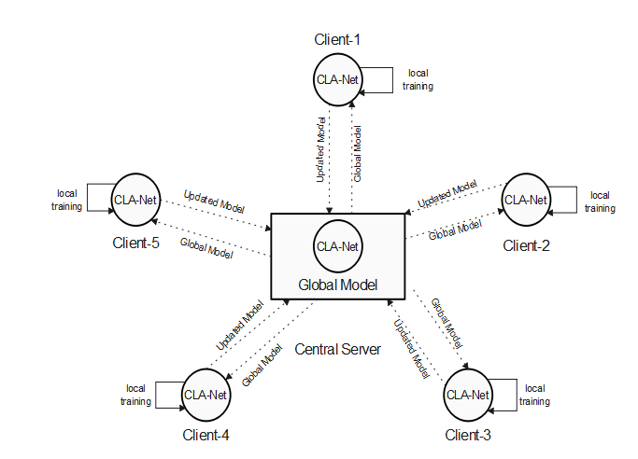
Figure 7: Federated Learning Architecture for CLA-Net
This decentralized learning helps in reducing the communication delays and maintains the data privacy, supporting an efficient distributed learning environment. In this Federated Learning architecture, the number of edge devices or clients are 5, and each device trains on the data that is distributed equally. As shown in Fig. 7, local clients train on raw data, and their aggregated weights, processed with FedProx and momentum-based aggregation, are sent to the global model present in the central server. Finally, the accuracy of the global model is evaluated.

D. DDoS Detection Module
The DDoS Detection Module runs the traffic monitoring to find signatures which point toward DDoS attacks. The system detects several attack types through its mechanism with a focus on processing SYN, UDP, LDAP, MSSQL, NetBIOS, UDPLag communications. Using the Federated Learning-trained CLA-Net model with regularized backpropagation and ReLU activation functions the module obtains high accuracy for recognizing normal from malicious traffic. This module handles efficient detection of attacks through dynamic environments by using optimizers including Adam for weight management selection. This module functions in real time while being decentralized which enables it to scale according to current threats.
Algorithm 1: Adaptive Federated Learning process.
Input: Global model (w₀), Dataset (X_{train}, Y_{train}, X_{val}, Y_{val}), Clients (C), Training rounds (T), Local model (w_{c}), Client weights (w_{t}), FedProx regularization parameter (μ), Momentum factor (m), Batch size (b)
Output: Trained global model ($w_{T}$)
1: | procedure Adaptive Federated Learning
2: | w₀ ← Initialize global model
3: | previous_weights ← w_{0.}get_weights()
4: | ClientDataSplit( X_{train},Y_{train},C)←Split dataset among clients
5: | for each communication round t = 1, 2, ... T do
6: | client_weights ← [ ] ← Store local weight updates
7: | for each client c ∈ C do
8: | w_{c} ← w_{t-1} ← Clone global model
9: | w_{c} ← TrainLocalModel(w_{c}, client_data[c], batch_size = b)
10: | local_weights ← w_{c}.get_weights()
11: | global_weights ← w_{t-1}.get_weights()
12: | for w₁, w₂ in zip(local_weights, global_weights)
13: | prox_term ← [w₁ - w₂]
14: | end for
15: | for w₁, w₂ in zip(local_weights, prox_term)
16: | updated_weights ← [w₁ - μ * w₂]
17: | end for
18: | client_weights.append(updated_weights)
19: | end for
20: | w_{t} ← MomentumAggregation(client_weights, previous_weights, m)
21: | UpdateGlobalModel(w_{t})
22: | previous_weights ← w_{t}
23: | EvaluateGlobalModel(w_{t}, X_{val}, Y_{val})
24: | end for
25: | return global model w_T
26: | end procedure
Algorithm 2: Momentum-Based Aggregation Function
Input: Momentum factor (m)
procedure Moment-Based Aggregation
function Momentum-Aggregation(client_weight, previous_weight, m)
new weight ← [ ]
for each weight index
for j in range (len(client weight))
median weight ← np.median(([client weight[j][i]])
new weights [i] ← (m*previous weight[i]) + ((1-m)* median-weight)
end for
end for
return new weights
end function
end procedure

The Adaptive Federated Learning Algorithm1 with FedProx and Momentum Aggregation algorithm trains a global model, denoted as w₀ , across multiple clients C over T rounds. First, the global model is initialized, and the weights are stored as reference for the future changes. The dataset, represented as (X_{train}, Y_{train}), is distributed among the C clients equally. In each round of Federated Learning, every client initializes the local model w_{c} by cloning the previous global model weights w_{t-1} and get trained by the data. After the training of each client, the updated local weights are obtained. To ensure the proper stability during the weight updates, a proximal term is initialized. Proximal term prox_term (8) is defined as the difference of local model's weights and the global model's weights.

prox_term = w_{local} – w_{global}…………………………… (8)
Using this prox_term, the client's updated weights are generated by applying the FedProx regularization parameter μ, which prevents large deviations from the global model weights (15).

w_{updated} = w_{local} – μ . prox_term………………………. (9)

Once all the clients complete their training, the server aggregates their weights. To ensure robustness, the median of all the client weight's is computed as calculation of median of each client in the system.
Once the above process is done, the momentum aggregation step takes place. This updates the global model by combining the previously stored global weights with the computed median weight. This is controlled by the momentum factor m, which balances the previous weights and the current client weights
After updating the global model, the performance is evaluated on the validation dataset (X_{val}, Y_{val}). This iterative process continues until the final trained model ​w_{T} is obtained.

- Results and Discussions

Hyperparameters and Metrics: To elucidate the model’s training dynamics, we table the hyperparameters employed in Table IV:
TABLE III
Hyperparameters used for training the FL based CLA-Net model.
Hyperparameter | Metrics
Learning rate | 0.001
Batch size | 32
Epochs | 3
Federated learning rounds | 25
Optimizer | Adam
Loss function | sparse categorical cross entropy
μ | 0.1
Momentum factor | 0.001

The proposed work follows decentralized training across 5 edge devices and data is split into one-fifth of data equally for each client accordingly, preserving data privacy and enhancing model performance. Unlike the traditional CNN, which suffers from limited scalability and overfitting, the proposed research work, Federated Learning algorithm FedProx for DDoS Detection System ensures scalability through multiple mechanisms. A decentralized approach is used instead of processing all the data by one model and model training is distributed across multiple edge devices, reducing the load on a single server. Adaptive Federated Learning with FedProx and Momentum Aggregation overcome scalability issues by reducing communication overhead. In Federated Learning, continuous communication between the clients and the server can cause the network congestion as the number of clients gets increasing. By using FedProx approach local model weights do not deviate too far from the global model weights. This results us fewer Federated Learning rounds, reducing the excessive data transmission. Then, a momentum-based weight aggregation is deployed. In the global model, weight is updated using FedProx, without requiring direct access to raw data. As a result, the CLA-Net with Federated Learning achieves superior performance of 99% compared to the conventional CNN model of 75%, making it a more reliable, scalable, and effective solution for DDoS detection. Fig. 8 represents the accuracy comparison of CNN and CLA-Net with Federated Learning.
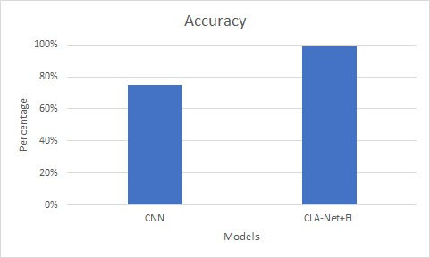
Figure 8: Accuracy comparison of CNN and CLA-Net+FL

Fig. 9 and Fig. 10 represents the confusion matrix for the CLA-Net with Federated Learning and individual CNN model. Confusion matrix is an evaluation tool for performance checking used in classification models to visualize the accuracy of predictions. It is a N x N where N represents the number of classes that are 7 (0-6), and it compares actual labels with predicted labels. The four important elements in a confusion matrix are True Positives (TP), False Positives (FP), True Negatives (TN), and False Negatives (FN). TP tells that are correctly classified positive cases, while FP denotes that the data is wrongly classified as positive. Similarly, TN represents correctly classified negative cases, and FN accounts for missed positive ones. Confusion matrix helps in calculating the accuracy, precision, recall and F1-score, which are important for testing the performance of a model.

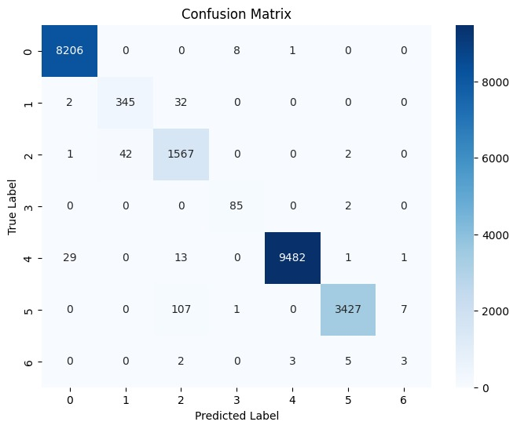
Figure 9: Confusion matrix for CLA-Net with Federated Learning

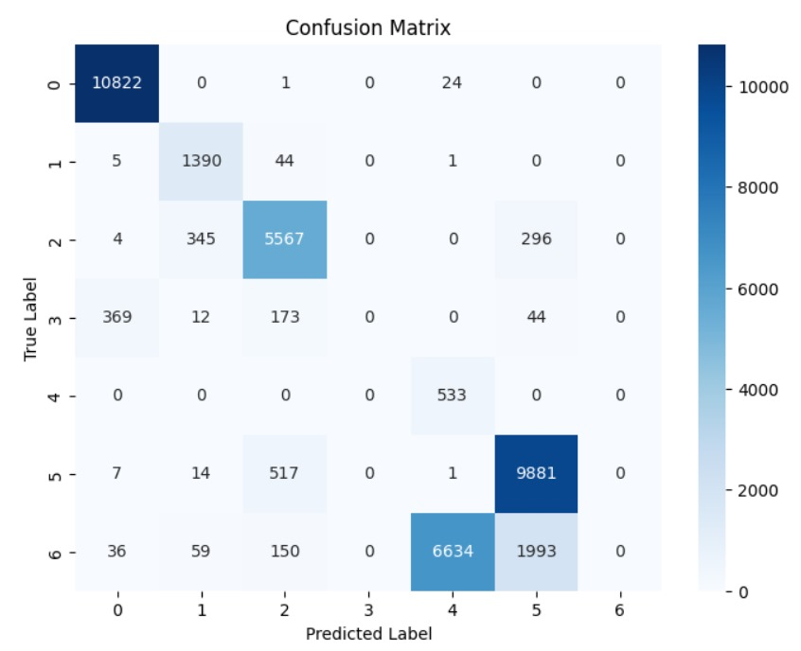
Figure 10: Confusion matrix for CNN

TABLE IV
Round | Client 1 | Client 2 | Client 3 | Client 4 | Client 5
Round-1 | 63.33% | 62.71% | 62.92% | 63.07% | 63.91%
Round-5 | 98.25% | 98.34% | 98.34% | 98.57% | 98.51%
Round-10 | 98.35% | 98.64% | 98.36% | 97.96% | 98.68%
Round-15 | 98.82% | 98.74% | 98.71% | 98.79% | 98.24%
Round-20 | 98.71% | 98.93% | 98.72% | 98.61% | 98.69%
Round-25 | 98.81% | 98.90% | 98.84% | 98.81% | 98.88%
ACCURACY FOR EACH CLIENT FOR EVERY FEDERATED ROUND
The accuracy of CLA-Net Federated Learning model across all the five different clients for every five rounds is shown in Table. V. In Round-1 the accuracies was very low which was around 63%, which tells us the CLA-Net model is in the early phase. A significant improvement was observed in Round-5, where accuracy jumped to approximately 98%. From Round-6 to Round-25, the accuracy showed a steady improvement around 99% for all clients. This indicates the model successfully learned typical patterns and achieved convergence.
Fig. 11 is the graphical representation of increased accuracy in every round of Federative Learning for the global model. The small variation in accuracy across clients suggests that the Federated Learning with FedProx framework was effective in maintaining consistency while improving generalization.
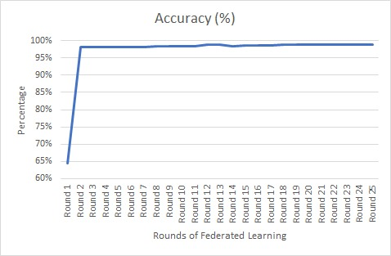
Figure 11: Accuracy for each round of Federated Learning

Fig. 12 represents the loss function values across different rounds of Federated Learning. Loss function is a key metric used to measure the difference between actual and the predicted outputs of the mode. In Fig. 13 as the rounds increases from round-1 to round-25, the loss values are gradually decreasing which indicated that the global model is learning efficiently and improving the accuracy. This also indicated that the model is becoming best at detecting the different types of DDoS attacks. This is done by Federated Learning algorithm that is FedProx, where the local models train on decentralized data, and their individual weights are averaged to refine the global model, reducing the errors in the prediction.
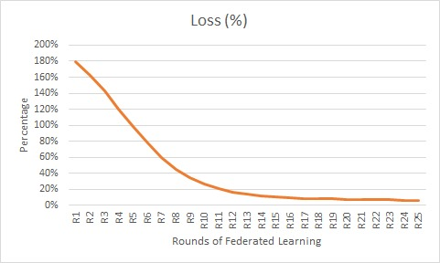
Figure 12: Loss for each CLA-Net with Federated Learning

TABLE V
PERFORMANCE METRICS FOR CNN-CLA-Net WITH FEDERATED LEARNING
Attacks | Precision (%) | Recall (%) | F1-Score (%)
Benign | 100% | 100% | 100%
LDAP | 89% | 91% | 90%
MSSQL | 91% | 97% | 94%
NetBIOS | 90% | 98% | 94%
Syn | 100% | 100% | 100%
UDP | 100% | 97% | 98%
The Table. VI presents the precision, recall, and F1-score for different types of DDoS attacks. The model achieved a high performance in identifying Benign traffic, with 100% precision and 100% recall, leading to a perfect F1-score of 100%. Syn attack was highly effective, achieving 100% precision, 100% recall and F1-score of 100%. LDAP and MSSQL attacks have slightly lower precision (89% and 91%) but high recall (91% and 97%) and F1-scores of 90% and 94%. These results suggest that the model correctly identified most of the attacks but there were some incorrect classifications that leads to lower precision. The Fig. 13 represents the performance metrics such as Precision, Recall and F1-Score for every individual DDoS attack.
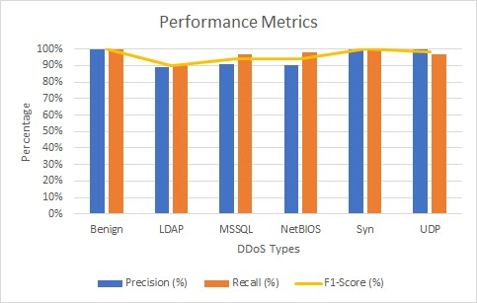
Figure 13: Performance metrics for Enhanced CNN-CLA-Net with Federated Learning

The results indicate that the federated learing with CLA-Net approach significally improves model performance across multiple training rounds, with final accuracy of 99%. The high recall values tells us that model effectively identified typical patterns correctly and coming to low recall for NetBIOS attack tells us an improvment, possibly providing additional data for fine tuning of model parameters. The results demonstrate the effectiveness of using Federated Learning combined with advanced deep learning techniques such as CLA-Net to detect DDoS attacks with data privacy. Future improvements include expanding the dataset to enhance the model and increase the recall for less frequently occuring attacks like NetBIOS.
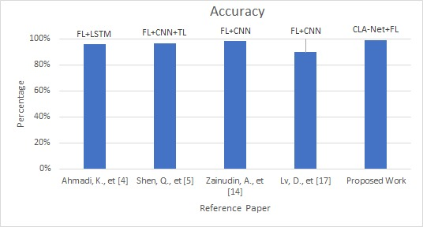
Figure 14: Comparison of Proposed work with existing studies

TABLE VI
COMPARISION OF PROPOSED WORK WITH EXISTING STUDIES
S.No | Reference number | Models | Accuracy
1 | Ahmadi, K., et [8] | FL+LSTM | 95.75%
2 | Pourahmadi, V., et [15] | FL | 97%
3 | Lv, D., et [21] | FL+CNN | 89.69%
4 | Neto, E. C. P., et [26] | FL | 84.8%
5 | Proposed Work | FL+CLA-Net | 99%

Fig. 14 and Table. VII speaks that the proposed work Federated Learning with CLA-Net (Convolution LSTM Attention Network) achieved the highest accuracy of 99% compared to the other Federated Learning based models such as LSTM and CNN which are evaluated on the same dataset, CICDDoS2019. Among the previous researches Federated Learning model performed best with 97% accuracy followed by Federated Learning with LSTM wat 95.75%. FL+CNN and individual FL has achieved an accuracy of 89.69% and 84.8%. The high performance of proposed work FL+CLA-Net model suggests that CLA-Net when combined with Federated Learning offer improved performance metrics and classification capabilities for DDoS attack detection, performing better than convolutional architectures. Further more, the use of FedProx with Momentum Aggregation in the proposed work further enhances model performance and stability, leading to better performance compared to FL+CNN, reinforcing that CLA-Net can outperform CNN using this federated Algorithm FedProx.

- Conclusion

The proposed Federated Learning approach FedProx with CLA-Net (Convolution LSTM Attention Network) based DDoS detection system achieve high accuracy while maintaining data privacy. The Data Preprocessing Module provides best and quality input to the model by handling missing values, normalization of data and extracting the features of network traffic, improving model performance across many client devices. The CLA-Net Architecture, optimized with ReLU and softmax activation functions, along with Lasso and Ridge regularization, prevents overfitting and improves model performance. The optimizers which are used like Adam improves the learning efficiency and learns the typical features that are extracted, leading to a detection accuracy of 99%. By incorporating Federated Learning i.e FedProx Framework, the system enables data privacy and decentralized model training, where the sensitive data regarding the network traffic remains on local devices that means client models while only weights of the models are updated by momentum aggregation all the weights between the nodes or neurons. The DDoS Detection Module effectively identifies multiple attack types, including Syn, UDP, LDAP, NetBIOS, MSSQL, and UDPLag achieving high precision, recall and F1-score of 95%, 97% and 96% respectively. The model demonstrates the monitoring capabilities and detecting different types of attack patterns with minimum false positives. Overall, this Federated Learning -driven DDoS detection system achieves 99% accuracy enhances cybersecurity resilience. Future work can focus on optimizing model efficiency for large-scale deployment and improving detection of not represented attack types.
- References
- https://cybersecurityventures.com/the-15-top-ddos-statistics-you-should-know-in-2020
- https://www.comparitech.com/blog/information-security/ddos-statistics-facts
- https://qrator.net/blog/details/2023-ddos-attacks-statistics-and-observations
- https://www.linkedin.com/pulse/artificial-neural-network-model-classification-regression-doug-rose-ucihe
- Bhatia, K., Bhattacharya, S., & Sharma, I. (2024, February). Privacy-Preserving Detection of DDoS Attacks in IoT Using Federated Learning Techniques. In 2024 IEEE International Conference on Big Data & Machine Learning (ICBDML) (pp. 234-239). IEEE.
- Ahmadi, K., & Javidan, R. (2023, July). DDoS Attack Detection in a Real Urban IoT Environment Using Federated Deep Learning. In 2023 IEEE International Conference on Cyber Security and Resilience (CSR) (pp. 117-122). IEEE.
- Li, K., Zhou, H., Tu, Z., Wang, W., & Zhang, H. (2020). Distributed network intrusion detection system in satellite-terrestrial integrated networks using federated learning. IEEE Access, 8, 214852-214865.
- Ferrag, M. A., Friha, O., Hamouda, D., Maglaras, L., & Janicke, H. (2022). Edge-IIoTset: A new comprehensive realistic cyber security dataset of IoT and IIoT applications for centralized and federated learning. IEEe Access, 10, 40281-40306.
- Nguyen, T. G., Phan, T. V., Hoang, D. T., Nguyen, T. N., & So-In, C. (2021). Federated deep reinforcement learning for traffic monitoring in SDN-based IoT networks. IEEE Transactions on Cognitive Communications and Networking, 7(4), 1048-1065.
- Li, J., Lyu, L., Liu, X., Zhang, X., & Lyu, X. (2021). FLEAM: A federated learning empowered architecture to mitigate DDoS in industrial IoT. IEEE Transactions on Industrial Informatics, 18(6), 4059-4068.
- Liu, Z., & Yin, X. (2021). LSTM-CGAN: Towards generating low-rate DDoS adversarial samples for blockchain-based wireless network detection models. IEEE Access, 9, 22616-22625.
- Alhasawi, Y., & Alghamdi, S. (2024). Federated Learning for Decentralized DDoS Attack Detection in IoT Networks. IEEE Access, 12, 42357-42368.
- Pourahmadi, V., Alameddine, H. A., Salahuddin, M. A., & Boutaba, R. (2022). Spotting anomalies at the edge: Outlier exposure-based cross-silo Federated Learning for ddos detection. IEEE Transactions on Dependable and Secure Computing, 20(5), 4002-4015.
- Zhang, J., Yu, P., Qi, L., Liu, S., Zhang, H., & Zhang, J. (2021, October). FLDDoS: DDoS attack detection model based on Federated Learning. In 2021 IEEE 20th International Conference on Trust, Security and Privacy in Computing and Communications (TrustCom) (pp. 635-642). IEEE.
- Kautish, S., Reyana, A., & Vidyarthi, A. (2022). SDMTA: Attack detection and mitigation mechanism for DDoS vulnerabilities in hybrid cloud environment. IEEE Transactions on Industrial Informatics, 18(9), 6455-6463.
- Dao, N. N., Phan, T. V., Sa’ad, U., Kim, J., Bauschert, T., Do, D. T., & Cho, S. (2021). Securing heterogeneous IoT with intelligent DDoS attack behavior learning. IEEE Systems Journal, 16(2), 1974-1983.
- Almadhor, A., Altalbe, A., Bouazzi, I., Hejaili, A. A., & Kryvinska, N. (2024). Strengthening network DDOS attack detection in heterogeneous IoT environment with federated XAI learning approach. Scientific Reports, 14(1), 24322.
- Doriguzzi-Corin, R., & Siracusa, D. (2024). FLAD: adaptive Federated Learning for DDoS attack detection. Computers & Security, 137, 103597.
- Lv, D., Cheng, X., Zhang, J., Zhang, W., Zhao, W., & Xu, H. (2022, March). Ddos attack detection based on cnn and Federated Learning. In 2021 Ninth International Conference on Advanced Cloud and Big Data (CBD) (pp. 236-241). IEEE.
- Fotse, Y. S. N., Tchendji, V. K., & Velempini, M. (2024). Federated Learning based DDoS attacks detection in large scale software-defined network. IEEE Transactions on Computers.
- Subramanian, G., & Chinnadurai, M. (2024). Hybrid quantum enhanced federated learning for cyber-attack detection. Scientific Reports, 14(1), 32038.
- Swati, Roy, S., Singh, J., & Mathew, J. (2025). Securing IIoT systems against DDoS attacks with adaptive moving target defense strategies. Scientific Reports, 15(1), 9558.
- https://www.kaggle.com/datasets/dhoogla/cicddos2019
- https://www.kaggle.com/datasets/dhoogla/cicdos2017
- https://www.kaggle.com/datasets/chethuhn/network-intrusion-dataset
- https://www.kaggle.com/datasets/dhoogla/csecicids2018

